***Lab 02 Report***

***Saitejasree Ramala***

***16172566***

***Application to generate a file for the activities using devices (Android smartphone, SensorTag)***

By modifying the given app1-app3-SensorTagGPS project sample code by following Tutorial 3. Firstly, a file is generated for sensor activity for different types of information i.e., Acceleration, Date, Gyroscope, Humidity and Temperature using the TI CC2541 SensorTag.

The application makes use of the different sensors i.e., IR Temperature, Humidity, Accelerometer, and Gyroscope to record ambient temperature, object temperature, relative humidity, proper acceleration (x, y, z), and orientation (x, y, z) at the default time interval of one second for all the sensors.

Sensors are enabled and the GATT server is set to listen for data updates each using the GATT callback methods and a counting variable that iterates each sensor:

1. The onServicesDiscovered() callback method resets the counter and calls setNextSensorCharacteristic().
2. setNextSensorCharacteristic() enables a sensor and invokes the onCharacteristicWrite() callback.
3. The onCharacteristicWrite() callback method calls enableNextSensorNotification().
4. enableNextSensorNotification() subscribes to data notifications for a sensor and invokes the onDescriptorWrite() callback.
5. The onDescriptorWrite() callback method advances the counter and calls setNextSensorCharacteristic() for the next sensor.

Inclusion of UUIDs for sensors:

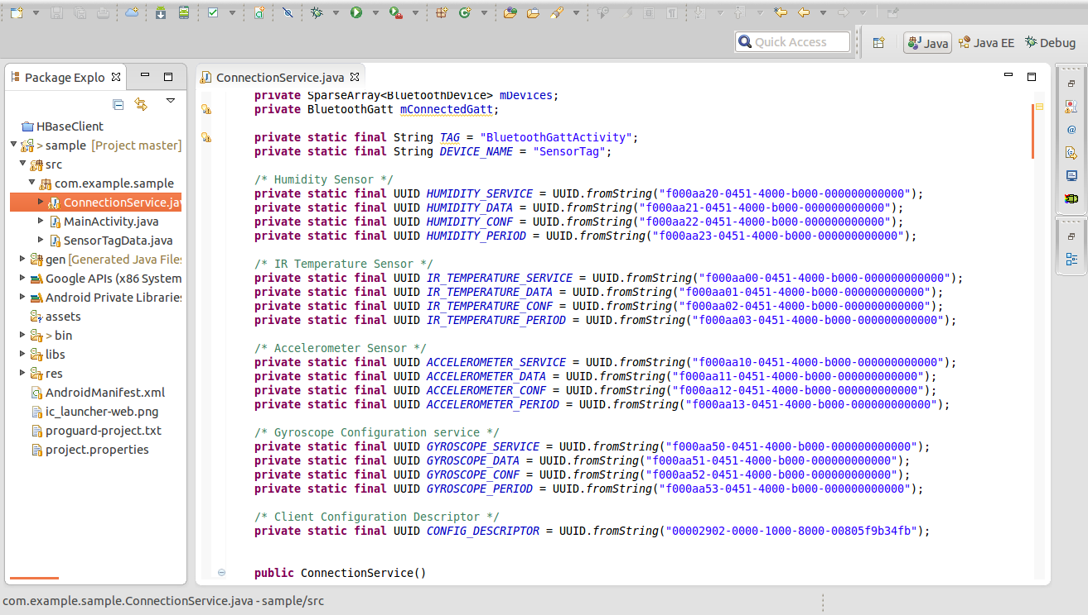

setNextSensorCharacteristic(): Here sensors are enabled by writing the configuration of 0x01 while Gyroscope makes use of 0x07 configuration.

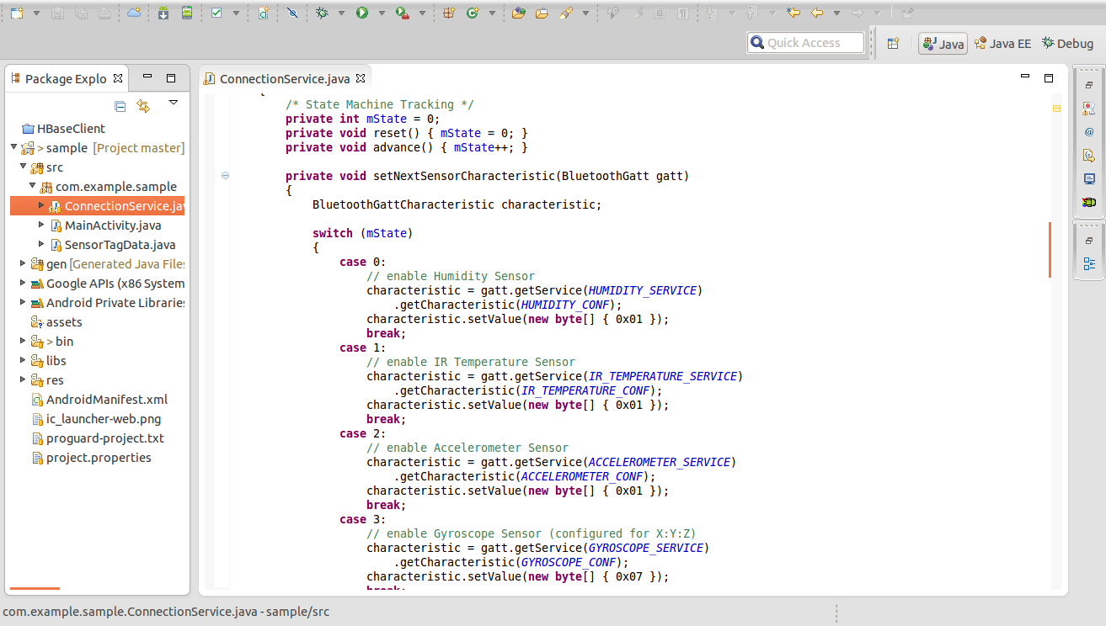

enableNextSensorNotification():

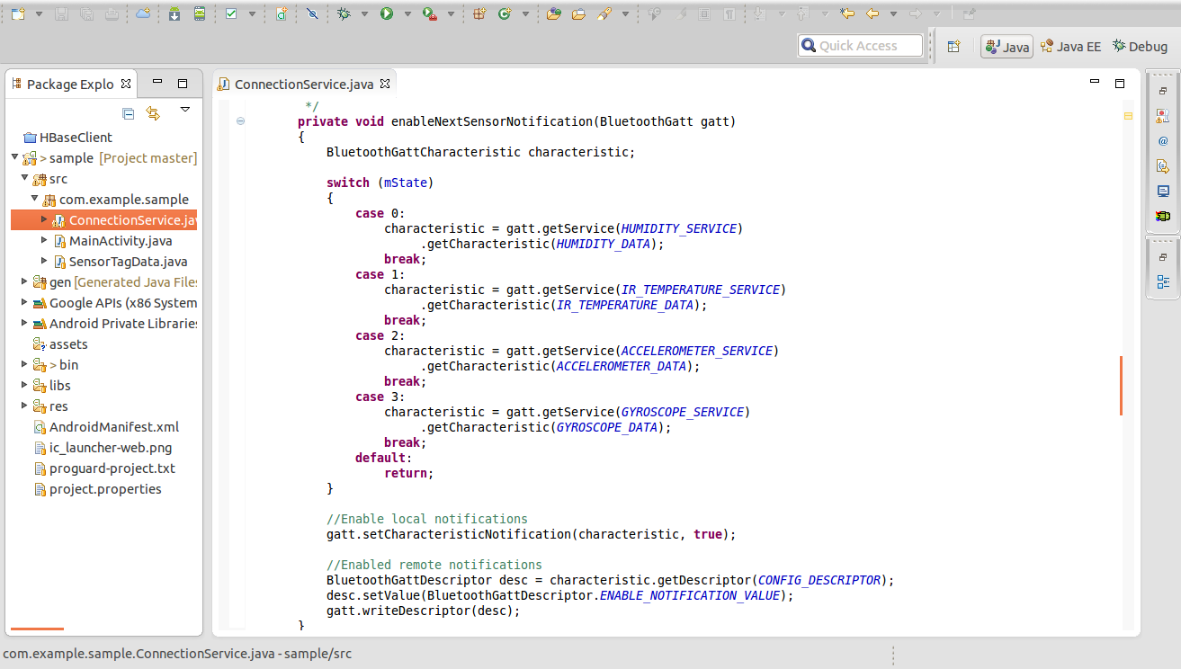

After the notifications for a given sensor are enabled, the onCharacteristcChanged() callback method is called at every interval for each sensor.  It calls static conversion functions in a SensorTag class in order to extract the raw data and converting it to a usable form.  It then calls the SaveData() function to write this data to a text file.

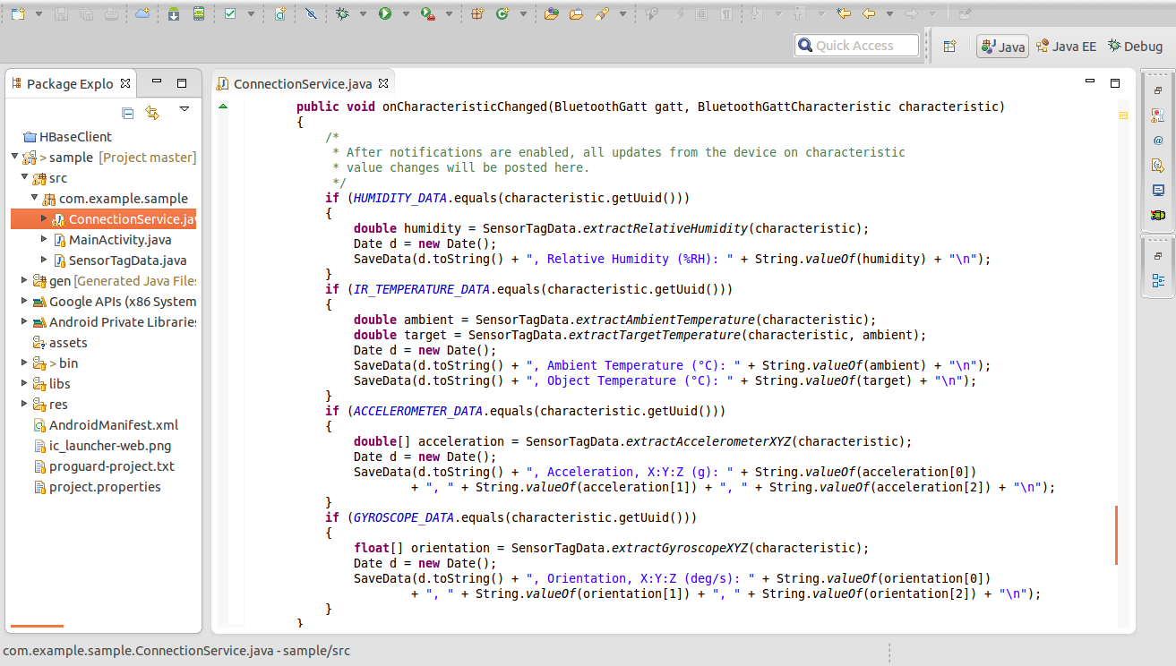

Raw data conversion functions borrowed from: <http://processors.wiki.ti.com/index.php/SensorTag_User_Guide>

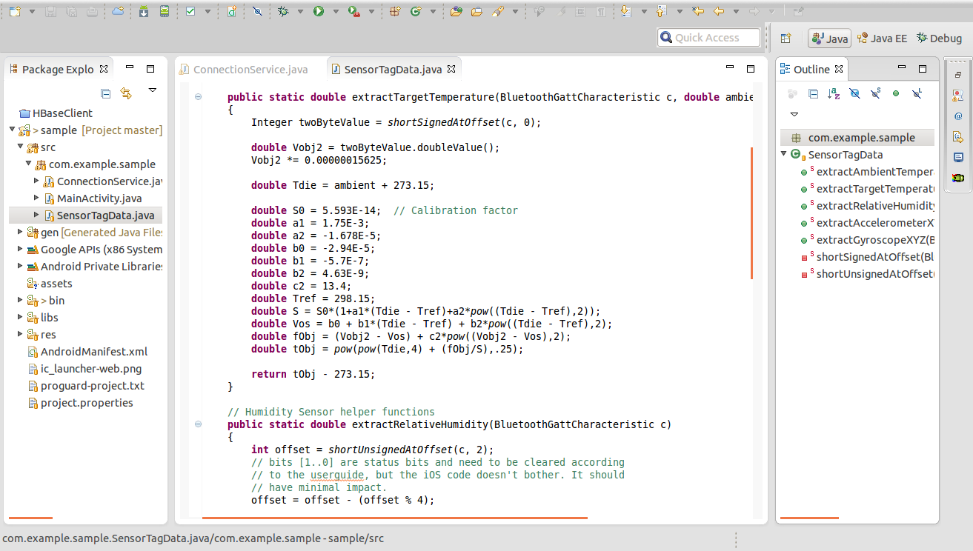

Output written to phone storage:

…

Sat Jun 21 23:27:31 CDT 2014, Orientation, X:Y:Z (deg/s): -164.04724, 99.28894, -215.39307

Sat Jun 21 23:27:31 CDT 2014, Relative Humidity (%RH): 29.202564239501953

Sat Jun 21 23:27:31 CDT 2014, Acceleration, X:Y:Z (g): 0.0625, -1.1875, -0.65625

Sat Jun 21 23:27:31 CDT 2014, Ambient Temperature (°C): 32.46875

Sat Jun 21 23:27:31 CDT 2014, Object Temperature (°C): 20.717300346350214

Sat Jun 21 23:27:32 CDT 2014, Orientation, X:Y:Z (deg/s): -193.34412, 214.79797, -24.795532

Sat Jun 21 23:27:32 CDT 2014, Relative Humidity (%RH): 28.958419799804688

Sat Jun 21 23:27:32 CDT 2014, Acceleration, X:Y:Z (g): 0.203125, -0.796875, -1.1875

Sat Jun 21 23:27:32 CDT 2014, Ambient Temperature (°C): 32.40625

Sat Jun 21 23:27:32 CDT 2014, Object Temperature (°C): 16.790920976928078

...

***HBase Client Application Implementation:***

Firstly, the HBaseClient.zip file is extracted and the HbaseClient.java file is imported into Eclipse. Then modified the given java file with respect to the sensor text file by making the necessary changes.

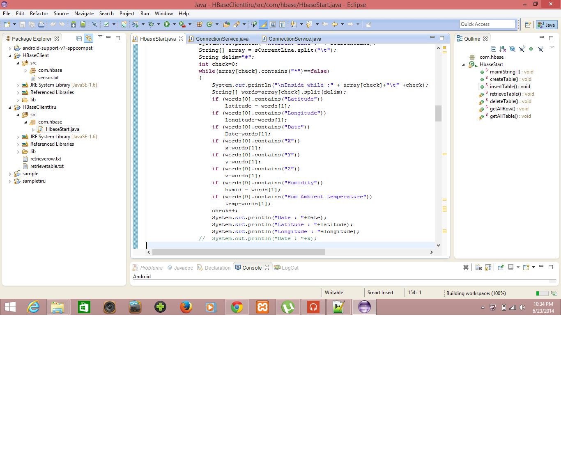

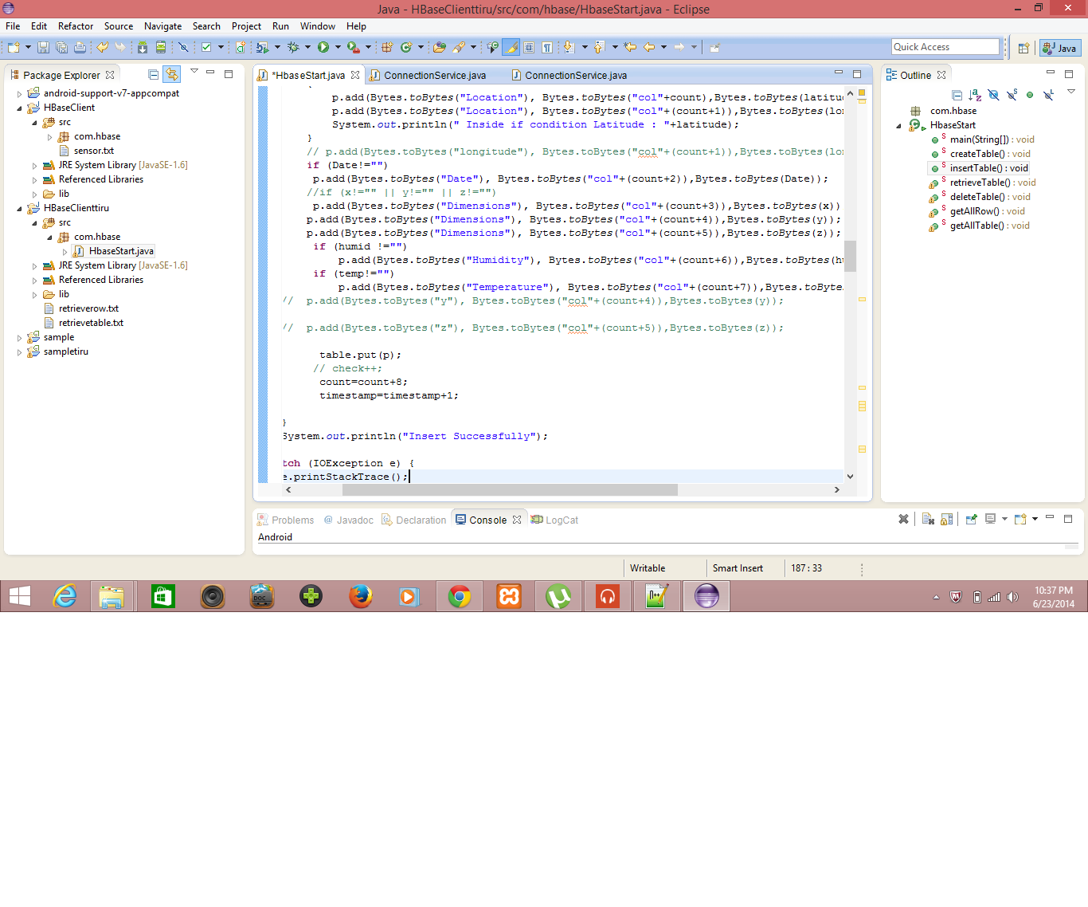

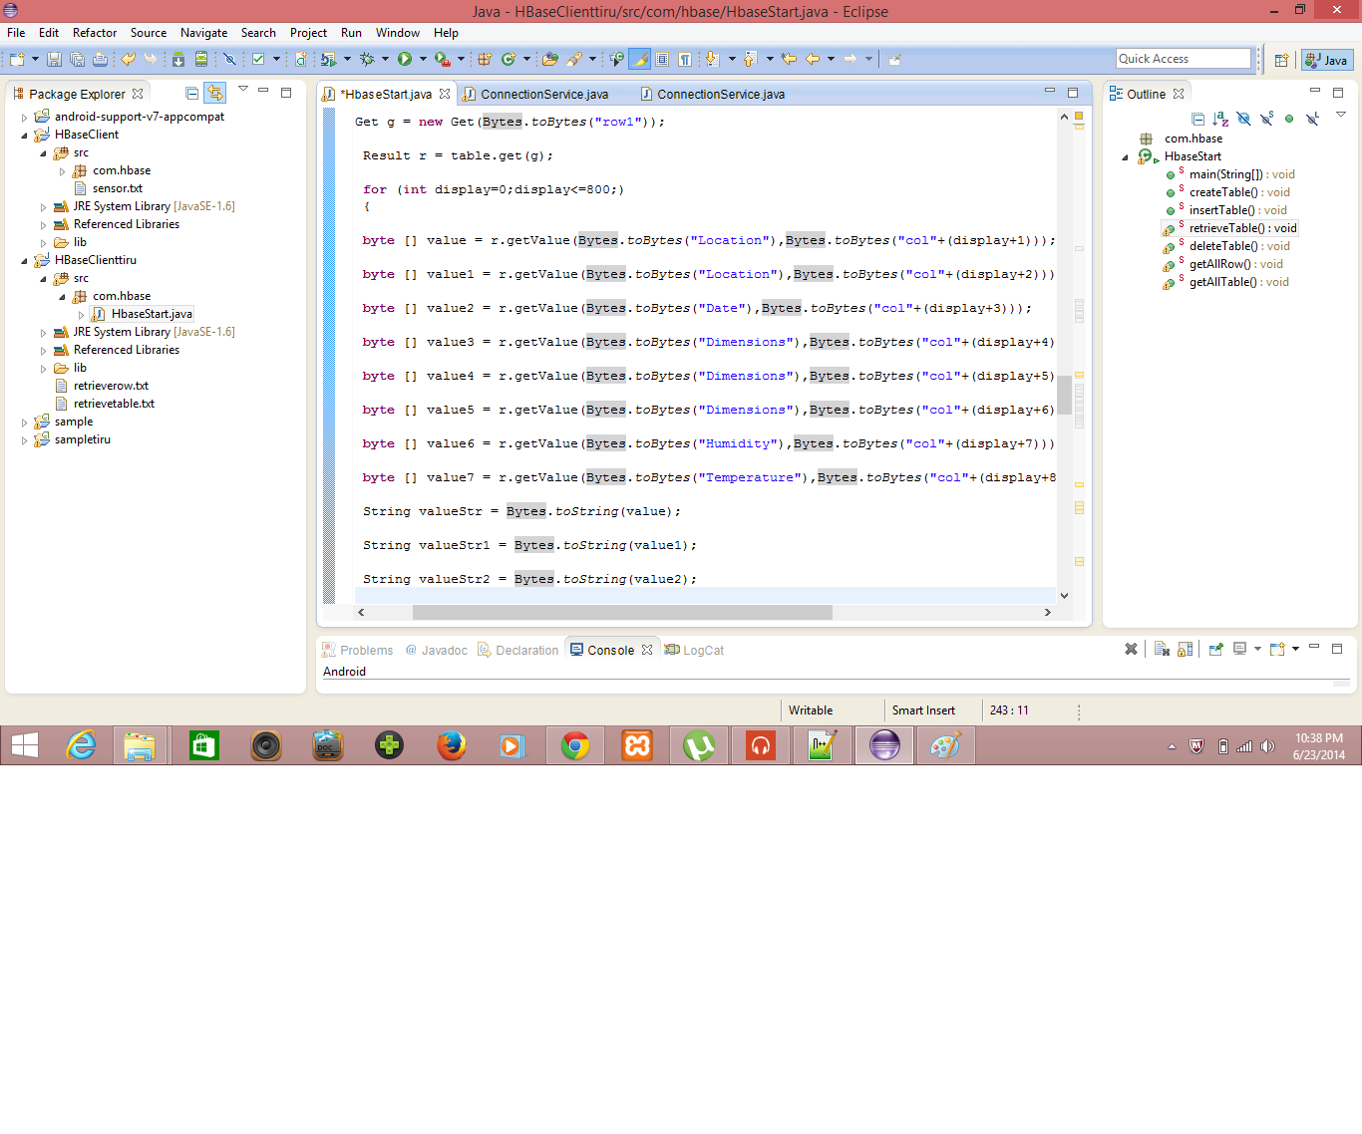

Then created a HBase Table as Group7Sensortable and then inserted data into it.

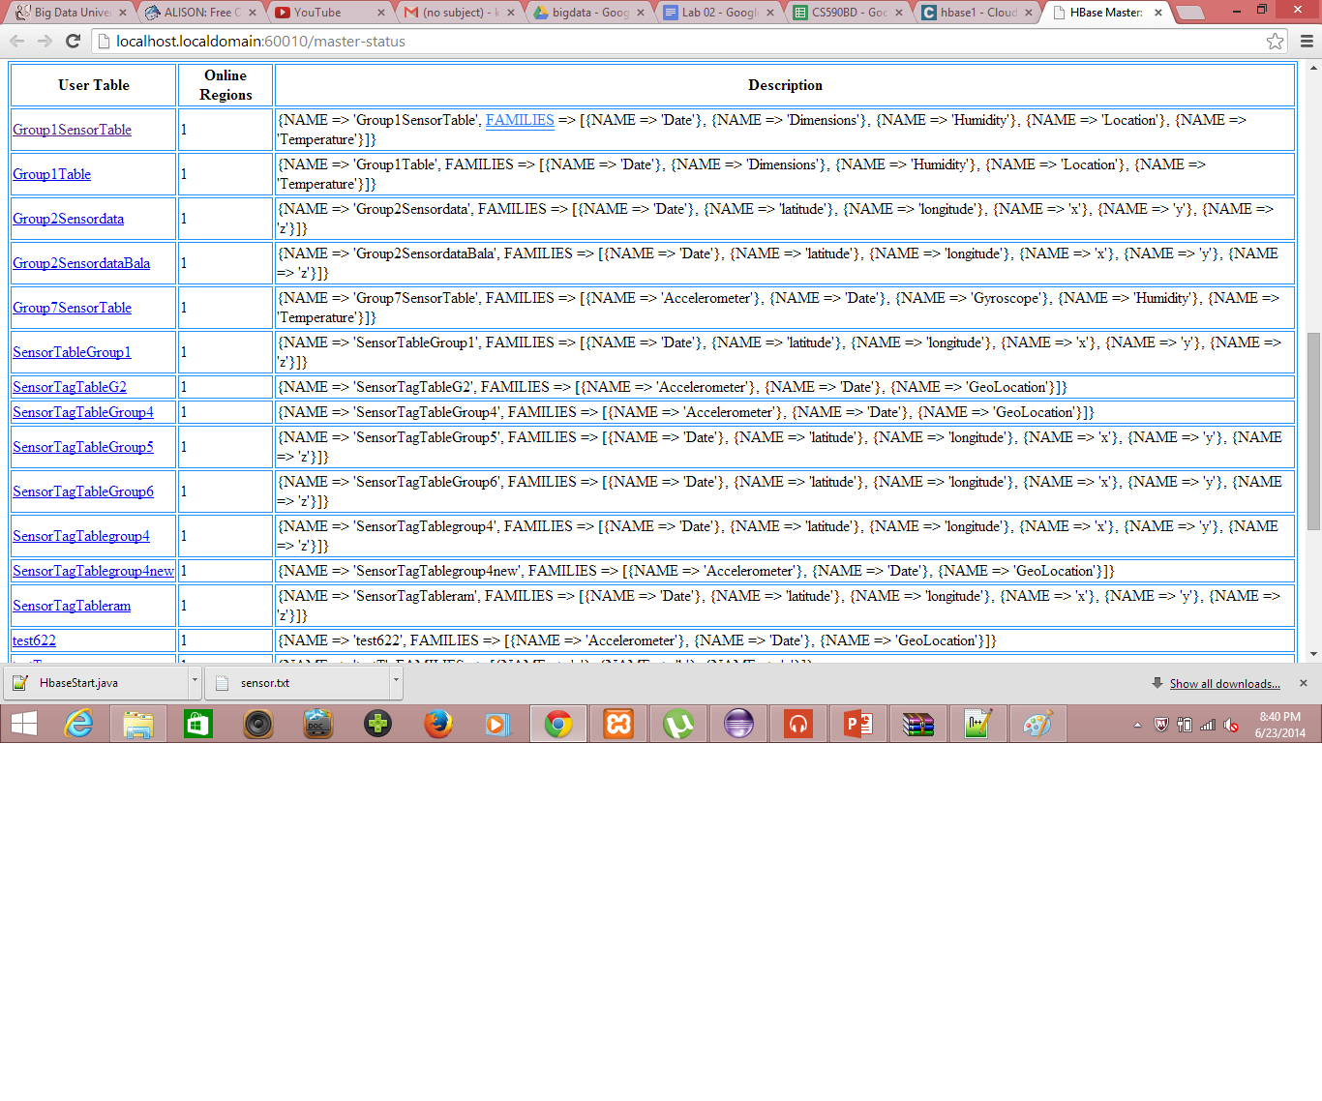

***Data Retrieval from HBase:***

And then finally retrieved data using the retrieveTable() from HBase.

